1.INTRODUCTION
Project Title: Weather-Based Prediction of Wind Turbine Energy Output: A Next-Generation Approach to Renewable Energy Management
Team ID: LTVIP2026TMIDS67101
Team Size: 4
Team Leader: Shaik Dariya Vali (228B1A4447)
Team member: Thalluri Sri Kalyan (228B1A4449)
Team member: Kavati Srinadh (228B1A4438)
Team member: Pallapothu Hemanth Satya Subramanyam (228B1A4443)
2. Project Overview
Purpose:
    - The purpose of this project is to predict wind turbine energy output using real-time weather data and machine learning techniques. It helps analyze how environmental factors influence renewable energy generation and supports efficient energy planning.
Features
    - Real-Time Weather Data Retrieval – Fetches live weather information such as temperature, humidity, pressure, and wind speed using a weather API.
    - Wind Energy Prediction – Uses a trained machine learning regression model to predict wind turbine energy output.
    - City-Based Weather Selection – Allows users to select a city to analyze local environmental conditions.
    - Input and Result Display – Shows user-entered input values along with predicted results for better clarity and analysis.
    - Simultaneous Weather and Prediction Display – Displays both weather data and energy prediction on the same page.
    - Machine Learning Model Integration – Loads a pre-trained model saved as a .pkl file for efficient prediction. User-Friendly Web Interface – Provides a simple and interactive
    - interface using HTML, CSS, and Flask.
3.Architecture
Frontend
- Built using HTML and CSS
- Uses Jinja templates to display dynamic data
- Provides forms for city selection and energy input
- Displays weather details and prediction results
Backend
- Developed using Python and Flask framework
    - Handles routing and form submissions
- Fetches real-time weather data using OpenWeatherMap API
- Loads and executes the trained machine learning model
- Manages session data to retain results
Data Layer
- Uses CSV dataset for model training
- Trained model saved as .pkl file
- No external database used

4.Setup Instructions
Prerequisites
Make sure the following software is installed:
- Python (version 3.8 or above)
- pip (Python package manager)
- Visual Studio Code or any code editor
- Internet connection (for Weather API access)
- OpenWeatherMap API Key
Installation Steps
1.Clone the Repository
git clone < https://github.com/Rushdagangapatla/Weather-based-prediction-of-windturbine-energy>
cd WINDENERGYPROJECT/flask_app
Or download and extract the project folder manually.
2.Create Virtual Environment (Recommended)
python -m venv venv
Activate it
3. Install Required Dependencies
pip install flask joblib requests python-dotenv
4. Set Up Environment Variables
Create a .env file inside the flask_app folder and add:
OPENWEATHER_API_KEY=your_api_key_here
5. Run the Application
python windApp.py

5. Folder Structure
• Frontend (Templates & Static Files)
templates/
- Contains HTML files such as intro.html and predict.html
- Uses Jinja templating to display dynamic weather and prediction data
static/
- Contains CSS files, images, and other static assets
- Handles styling and visual design of the web pages

• Backend (Flask Application)
windApp.py
- Main Flask application file
- Handles routing, API calls, prediction logic, and session management
power_prediction.pkl
- Pre-trained machine learning model used for prediction
.env
- Stores environment variables such as the Weather API key
model_training/
- Contains dataset (.csv)
- Training scripts for building the ML model
7. API Documentation
7.1. Home Endpoint
Endpoint: /
Method: GET
Description: Loads the home (intro) page of the application.
Parameters: None
Response:
Returns the intro.html page.

7.2. Prediction Page Endpoint
Endpoint: /predict
Method: GET
Description: Loads the main prediction interface page.
Parameters: None
Response:
Returns the predict.html page with stored session data (if available).

7.3. Weather API Endpoint
Endpoint: /windapi
Method: POST
Description: Fetches real-time weather data for the selected city.
Request Parameters:
Parameter | Type | Description
city | String | Name of the selected city (e.g., Vijayawada,IN)
Example Request (Form Data):
city=Vijayawada,IN

Example Response (Rendered on Page):
Temperature: 30 °C
Humidity: 70 %
Pressure: 1008 hPa
Wind Speed: 3.2 m/s
If error occurs:
Weather Error: City not found

7.4. Wind Energy Prediction Endpoint
Endpoint: /y_predict
Method: POST
Description: Predicts wind turbine energy output using the trained machine learning model.
Request Parameters:
Parameter | Type | Description
theo | Float | Theoretical power value (kWh)
wind | Float | Wind speed value (m/s)
Example Request (Form Data):
theo=1500
wind=5.5
Example Response (Rendered on Page):
Predicted Energy Output: 1320.45 Kw
If invalid input:
Please enter valid numeric values.
External API Used
OpenWeatherMap API
Used to fetch real-time weather data.
Base URL:
http://api.openweathermap.org/data/2.5/weather
Required Parameters:
- q (city name)
- appid (API key)
- units=metric
9. User Interface
The Wind Energy Prediction Web Application provides a simple and interactive user interface that allows users to fetch real-time weather data and predict wind energy output.

9.1. Home Page (Intro Page)
- Displays project title and description
- Navigation option to access prediction page
- Clean and simple layout
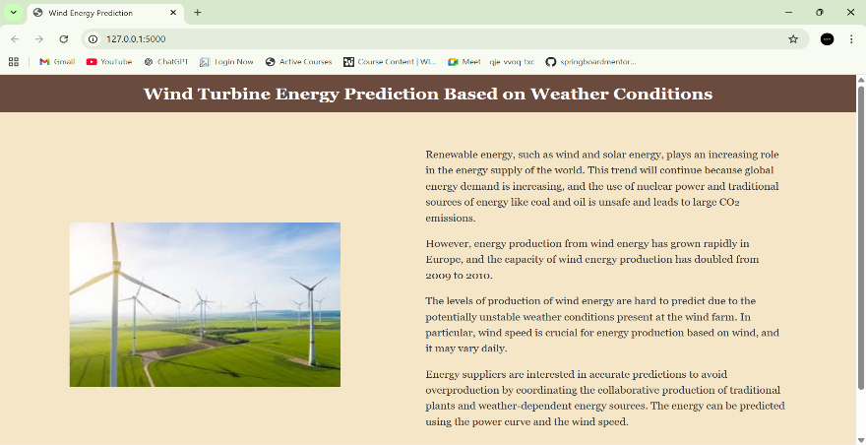
2. Weather Selection Interface
- Dropdown menu to select city
- Button to fetch weather conditions
- Displays temperature, humidity, pressure, and wind speed
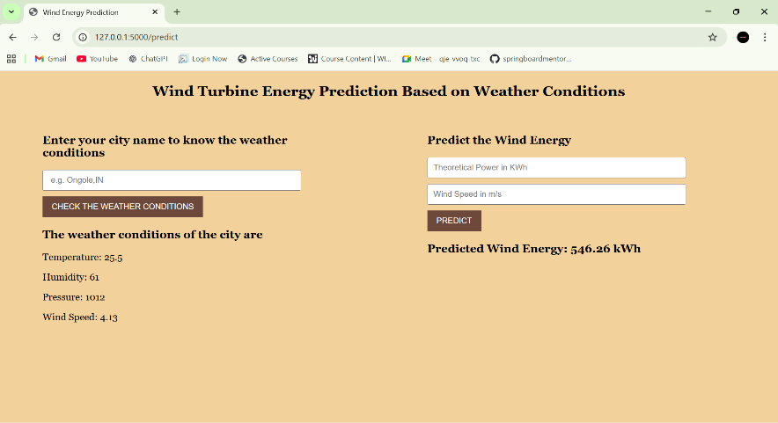
3. Wind Energy Prediction Interface
- Input fields for:
  - Theoretical Power (kWh)
  - Wind Speed (m/s)
- Predict button to generate output
- Displays predicted energy output
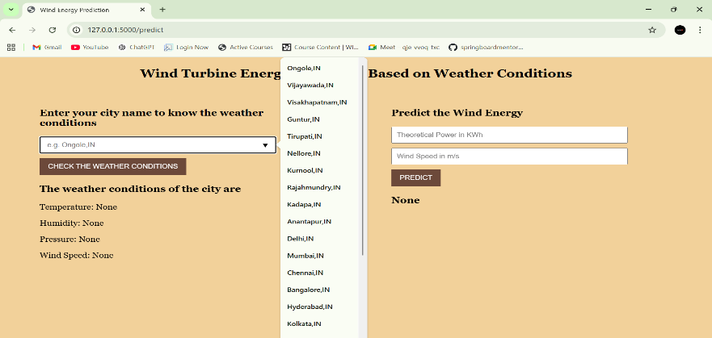
4. Combined Results Display
- Shows:
  - Selected city
  - Weather details
  - User input values
  - Predicted energy output
- Both weather and prediction results remain visible simultaneously
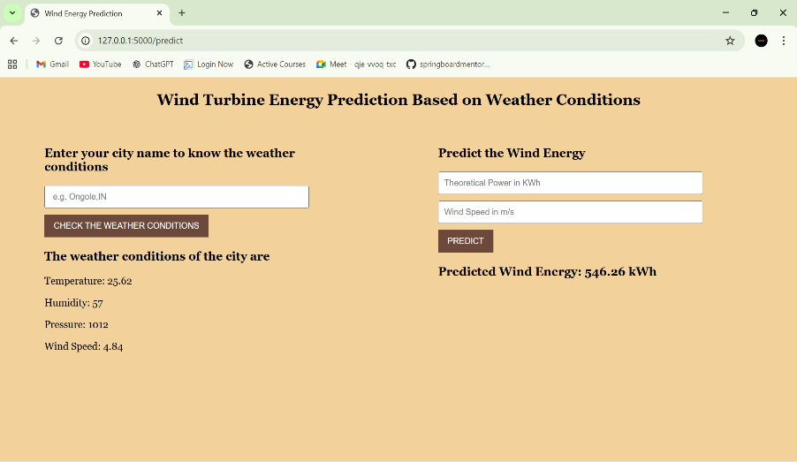

10. Testing
Testing Strategy
The Wind Energy Prediction Web Application was tested using manual and functional testing methods to ensure correct weather data retrieval and accurate energy prediction.
The testing process included:
- Verified that all routes (/, /predict, /windapi, /y_predict) function correctly.
- Tested real-time weather data retrieval for multiple cities.
- Validated user inputs for wind speed and theoretical power to prevent invalid entries.
- Confirmed that the machine learning model generates predictions accurately.
- Ensured that weather details and prediction results remain visible simultaneously using session handling.
- Checked error handling for invalid city names and incorrect input values.

Testing Tools Used
- Google Chrome – For testing user interface and functionality.
- Flask Debug Mode – For backend debugging and error tracking.
- VS Code Terminal – For monitoring server execution logs.
- Python Logging/Print Statements – For verifying API responses and prediction outputs.

11. Demo
Link:https://drive.google.com/file/d/1yNk_HwU6fxBCubl6OlmCyTdihG4euH0l/view?usp=sharing
12. Known Issues
- The application depends on the OpenWeatherMap API; if the API service is unavailable or the internet connection is weak, weather data cannot be retrieved.
- Incorrect or improperly formatted city names (without country code) may result in API errors or inaccurate weather results.
- The prediction accuracy depends on the quality and size of the dataset used to train the machine learning model.
- The application does not implement user authentication or role-based access control.
- The system currently runs in development mode and is not optimized for production deployment.
- There is no database integration; session data is temporary and will be cleared when the server restarts.

13. Future Improvements
- Implement user authentication and role-based access control to allow personalized user experiences.
- Integrate a database (such as MongoDB or MySQL) to store historical weather data and prediction records.
- Improve prediction accuracy by training the model with a larger and more diverse dataset.
- Add graphical visualizations (charts and dashboards) to display weather trends and energy output analysis.
- Deploy the application on a cloud platform for public access and scalability.
- Implement automatic wind speed fetching from weather data to auto-fill prediction inputs.
- Optimize the application for mobile responsiveness and improved user interface design.
- Add multiple renewable energy prediction modules such as solar energy forecasting.

